Project Planning Phase
Project Planning Template (Product Backlog, Sprint Planning, Stories, Story points)
TEAM MEMBERS | Abiyavincy D  Berlin K  Jemilda J  Kerin Shinu VS
PROJECT NAME | Project- Real Time River Quality Monitoring and Control System.
Product Backlog, Sprint Schedule, and Estimation (4 Marks)
Use the below template to create product backlog and sprint schedule
Sprint | Functional  Requirement  (Epic) | User story  Numb err | User Story / Task | Story Points | Priority | Team  Members
Sprint-1 | Registration | USN-1 | As a user, I canregister for the application by entering my email, password, and confirming My password. | 2 | HIGH | SURIYAPRAGASM  VENKATESAN  VIGNESH M(85)  VIGNESH M(86)
Sprint-1 | Registration via Facebook | USN-3 | As a user, I can register for the  application through Facebook | 2 | LOW | SURIYAPRAGASM  VENKATESAN  VIGNESH M(85)  VIGNESH M(86)
Sprint-1 | Registration via Mail ID | USN-4 | As a user, I can register for the application through Gmail | 2 | MEDIUM | SURIYAPRAGASM  VENKATESAN  VIGNESH M(85)  VIGNESH M(86)
Sprint-2 | Confirmation | USN-2 | As a user, I will receive confirmation email once I have registered for the application | 1 | HIGH | SURIYAPRAGASAM  VENKATESAN
Sprint-2 | Login | USN-5 | As a user, I can log into the  application by entering email & password | 1 | HIGH | SURIYAPRAGASAM  VENKATESAN
 | IBM Cloud service  Access | USN-5 | Get access to IBM cloud services. | 2 | HIGH | SURIYAPRAGASAM  VENKATESAN
Sprint-3 | Create the IBM Watson IoT and device Settings | USN-6 | To create the IBM Watson IoT Platform and integrate the microcontroller with it, to send the sensed data on  Cloud | 2 | HIGH | VIGNESH M (85)  VIGNESH M(86) VENKATESAN  SURIYAPRAGASAM
Sprint-3 | Create a node red service | USN-7 | To create a node red service to | 2 | MEDIUM | VIGNESH M (85)  VIGNESH M(86) VENKATESAN  SURIYAPRAGASAM
Sprint | Total  Story  Points | Duration | Sprint Start Date | Sprint End  Date(Planned) | Story Points  Completed (as on  Planned End Date) | Sprint Release  Date  (Actual)
Sprint-1 | 20 | 4 Days | 24 Oct 2022 | 27 Oct 2022 | 20 | 29 Oct 2022
Sprint-2 | 20 | 5 Days | 28 Oct 2022 | 01 Nov 2022 | 20 | 04 Nov 2022
Sprint-3 | 20 | 8 Days | 02 Nov 2022 | 09 Nov 2022 | 20 | 11 Nov 2022
Sprint-4 | 20 | 9 Days | 10 Nov 2022 | 18 Nov 2022 | 20 | 19 Nov 2022
 |  |  | integrate the IBM Watson along with the Web UI |  |  | VIGNESH M(86)  SURIYAPRAGASAM  VENKATESAN
 | Create a Web UI | USN-8 | To create a Web UI, to access the data from the cloud and display all parameters. | 2 | MEDIUM | VIGNESH M(86)  SURIYAPRAGASAM  VENKATESAN
 | To develop a Python code | USN-9 | Create a python code to sense the physical quantity and store data | 2 | MEDIUM | VIGNESH M(86)  SURIYAPRAGASAM  VENKATESAN
Sprint-4 | Publish Data to cloud. | USN-10 | Publish Data that is sensed by the microcontroller to the Cloud | 3 | HIGH | VENKATESAN  SURIYAPRAGASAM  VIGNESH M(85)
Sprint-4 | Fast-SMS Service | USN-11 | Use Fast SMS to send alert messages once the parameters like pH, Turbidity and temperature goes beyond the threshold | 3 | HIGH | VENKATESAN  SURIYAPRAGASAM  VIGNESH M(85)
Sprint-4 | Testing | USN-12 | Testing of project and final deliverables | 3 | MEDIUM | VENKATESAN  SURIYAPRAGASAM  VIGNESH M(85)

Velocity:
Imagine we have 10-day sprint duration, and the velocity of the team is 20 (points per sprint). Let’s calculate the team’s average velocity (AV) per iteration unit
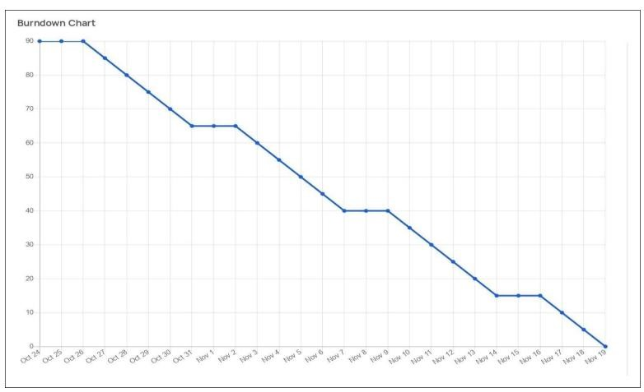
(story points per day)
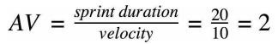
Burndown Chart:
A burn down chart is a graphical representation of work left to do versus time. It is often used in agile software development methodologies such as Scrum. However, burn down charts can be applied to any project containing measurable progress over time.

